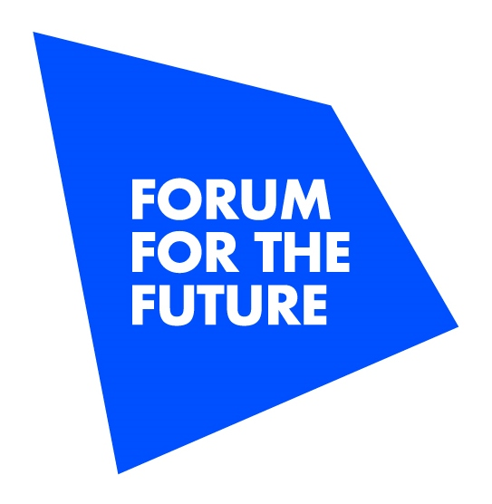

Forum for the Future strengthens leadership team with six new appointments to its Board of Trustees

Appointments reflect the organisation’s growing focus on international impact and exploring new approaches to tackling global sustainability issues

**00:01 GMT, London, 25 June 2019 –** International sustainability non profit Forum for the Future has announced six new appointments to its Board of Trustees in a bid to use new insights and experience to strengthen its work in the UK and internationally.

Charlotte Ersbøll, Noa Gafni, Heather Grady, Laura McGonigal, Jonny Wates and Andrew Winston will work alongside the non-profit’s existing Trustees to advise Forum on its mission to address critical global challenges by catalysing change in key systems - particularly food, energy, value chains and livelihoods.

This will involve providing strategic direction and support to the organisation’s multi-stakeholder collaborations, partnerships with leading businesses and other pioneering organisations, and activities to build a global community of change makers. The new appointments will also provide guidance on developing Forum’s work across Asia Pacific and the US as it continues to invest in new markets with the potential for long-lasting, transformational change.

**Keith Clarke, Chair of Forum for the Future, commented*:*** *“I’m thrilled to welcome Charlotte, Noa, Heather, Laura, Jonny and Andrew. They each bring with them vast experience and expertise in developing and delivering sustainable solutions across wide-ranging sectors, industries and markets. The world around us is changing in complex and unpredictable ways, meaning business as usual throughout the sustainability sector no longer applies. Innovation is key to tackling major global challenges like the climate emergency, and the Board will now bring fresh new guidance and perspectives that will revitalise and focus our efforts.”*

**Charlotte Ersbøll** is a senior advisor to the United Nations Global Compact and a partner in Hansen & Ersbøll Agenda, and brings with her more than 30 years’ experience in driving social impact through partnerships. She is co-founder and chairwoman of citizen-led movement *’iLoveGlobalGoals’,* which seeks to empower young people in making the Global Goals everyday goals. Previously, Charlotte headed Novo Nordisk’s global stakeholder engagement work, leading the development and execution of its sustainability strategy.

**Noa Gafni** is a Cambridge and Harvard affiliated expert on social innovation. An entrepreneur, Noa brings extensive experience in digital media and communications. Her previous roles include Global Leadership Fellow at the World Economic Forum and Head of Communications for the Global Shapers Community. Noa is currently a Social Innovation Fellow at the University of Cambridge, an affiliate at Harvard's Berkman Klein Center for Internet and Society, and regularly contributes to the Harvard Business Review, Huffington Post and New York Times.

**Heather Grady** is Vice President in the San Francisco office of Rockefeller Philanthropy Advisors and leads the organization’s strategy in global philanthropy. She leads the *Scaling Solutions* *Toward Shifting Systems* initiative, which encourages funders to collaborate on systemic approaches that deliver long-lasting impact. She also helped create the Sustainable Development Goal (SDG) Philanthropy Platform to engage philanthropy in the SDGs. In previous roles, Heather managed humanitarian programmes for a range of international development charities.

**Laura McGonigal** leads on the sustainability agenda for the Ecover and Method brands in Europe. She has a passion for systems change and believes in the power of brands to make the world a better place. In her role, she’s on a mission to create sustainable products and programmes that will catalyse change in the industry. Prior to this, Laura led product sustainability at Walgreens Boots Alliance and Reckitt Benckiser.

**Jonny Wates** is owner and Board member of the Wates group and brings a strong focus on operational sustainability. Jonny has held previous roles at IDV (now Diageo) and was Founder and Chairman of the renewable energy start up, Myriad Cleaner Energy Generation. Beyond his role at Wates, Jonny is an Associate at Leaders’ Quest and Vice Chair of Polaris, the sustainability programme of Family Business Network International. He is also an Advisory Council member of Commonland.

**Andrew Winston** advises many of the world’s leading companies – from HP and J&J to PepsiCo and PwC - on how to navigate and profit from solving humanity’s biggest challenges. He is a globally recognized speaker and writer on business strategy and mega-trends. Andrew is the author of *The Big Pivot* and co-wrote the international bestseller *Green to Gold.*

**Forum for the Future’s Chief Executive, Sally Uren, commented:** *“Our new appointments mark an important transition in Forum’s governance from a primarily UK-focused organisation to an increasingly international one. New international insights and knowledge will be key to delivering the whole-sale systems change so urgently needed if we’re to tackle the global sustainability challenges we face. Our new Board members will help to deepen and accelerate our impact across geographies and sectors.”*

The six new Trustees join Keith Clarke and Forum’s existing Board members: Volker Beckers; Kelvyn Derrick OBE; one of the organisation’s original founders, Jonathon Porrit CBE; Fiona Thompson and Anita Tiessen.

**-ENDS-**

For more information, please email [a.langridge@forumforthefuture.org](mailto:a.langridge@forumforthefuture.org).

**NOTES TO EDITORS**

**Full Trustee biographies**

Full Trustee biographies and quotes are available on the [Forum website](https://www.forumforthefuture.org/Pages/Category/our-governance).

**About Forum for the Future**

Forum for the Future is a leading international sustainability non-profit with offices in London, New York, Singapore and Mumbai. We specialize in addressing critical global challenges by catalysing change in key systems. For over 20 years, we’ve been working in partnership with business, governments and civil society to accelerate the shift toward a sustainable future. Together we are reinventing the way the world works.

Find out more at [www.forumforthefuture.org](http://www.forumforthefuture.org) or by following [@Forum4theFuture](http://www.twitter.com/Forum4theFuture) on Twitter